QUESTION 2

**Excel Lab 1: Euler’s Method**

*In this spreadsheet, we learn how to implement Euler’s Method to approximately solve an initial-value problem (IVP).*

We will describe everything in this demonstration within the context of one example IVP:

*dydx* = *x* + *y*.

# *y*(0) =1

We begin by creating four column headings, labeled as shown, in our Excel spreadsheet. (Skip a few lines at the top of the spreadsheet, as in the example below.) Our spreadsheet now looks like this:

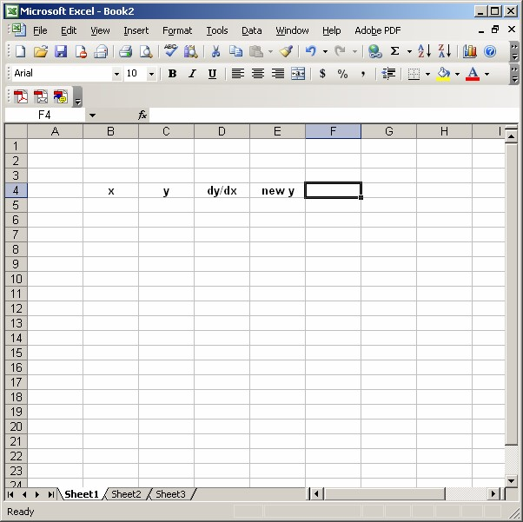

Somewhere above your table headings, label a cell “timestep”, and enter the timestep size you want to use in the cell next to it, like this:

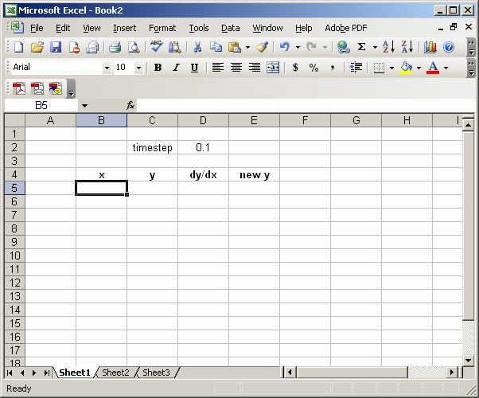

Next, enter the values of the initial condition in the first two columns, as shown:

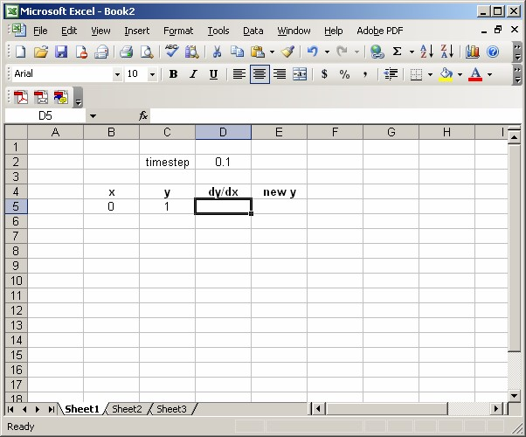

Next, we will complete the column of values of *x*, by using the fact that each *x*-value is the previous *x*-value plus the timestep. So, to compute the second *x*-value in the x column, we enter the following formula into cell B6:

# =B5+D$2

(Note the use of the $ in the cell address for the timestep. Refer to Excel Lab 1 if you have forgotten what this means.) This results in the value 0.1 appearing in cell B6. Now, highlight and drag cell B6 down the column, until you reach the desired ending value. For example, if we choose to stop Euler’s Method at *x=*1, our spreadsheet would look like this:

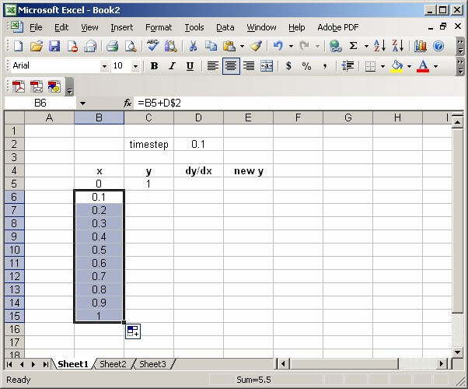

Next, we use the right-hand side of the differential equation to compute the value for the first cell in the dy/dx column. Specifically, we enter the formula

# =B5+C5

where, as usual, we have substituted cell addresses in place of *x* and *y*. Here’s what we get:

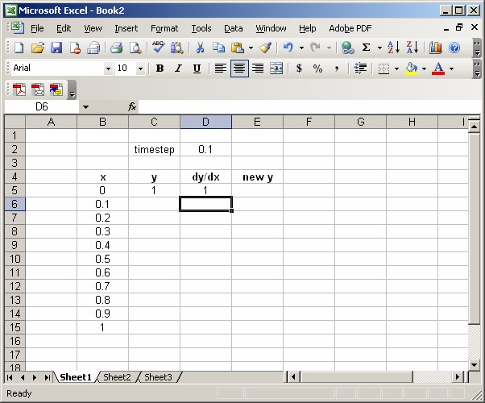

Next, we enter the formula for the tangent line approximation to *y*, built at the current value of *x* (*x=*0 in this example), and evaluated at the next *x*-value in the table (which would be *x=*0.1 in this example). The usual tangent line formula

# *L*(*x*) = *y*(0) + *y*'(0)(*x* − 0)

translates into the Euler’s Method formula

new y = y + dy/dx*timestep,

which, in turn, becomes the Excel formula (to be entered in cell E5)

# =C5+D5*D$2

Our spreadsheet now looks like this:

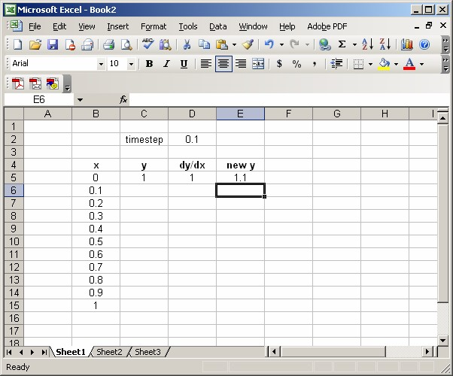

Next, we enter the next *y*-value in the table. This is simply the first entry in the “new y” column. Hence, we enter the following into cell C6:

# =E5

This moves the value 1.1 into the y column.

Next (We’re almost done!), highlight the first cells in the last two columns, and drag them down one row to complete the second column of the table. Here’s what we get:

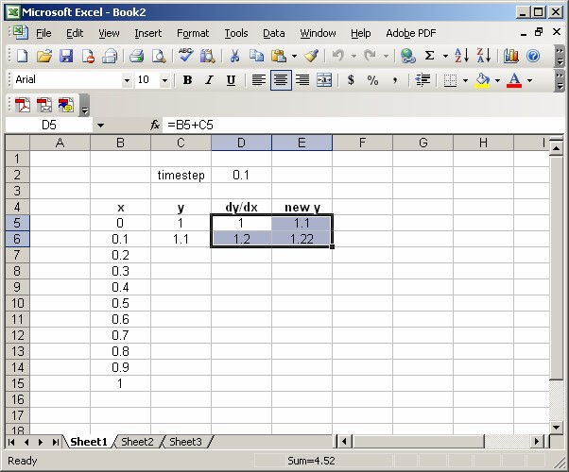

Finally, we complete the table by highlighting the second entries in the last three columns, and dragging them down as far as the *x*-column goes. This gives us this:

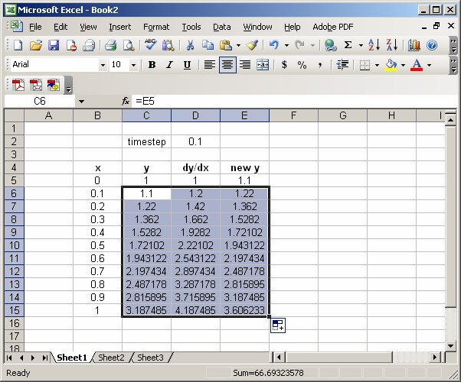

Extending the Table:

If we want to extend our table to larger values of *x*, all we must do is highlight the bottom row of the current table, and drag it down, as far as we want. For example, if we wanted to extend our example table to *x=*2, we select the *x=*1 row, and drag down ten cells, to get this:

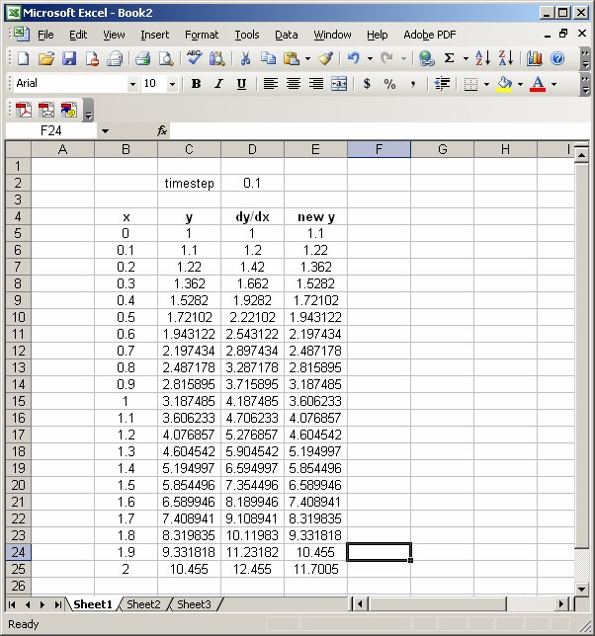

Of course, we can also create a plot of our approximate solution, in the usual way. Following the usual process (as described in Excel Lab 2), we can create a plot of the first two columns that looks like this:

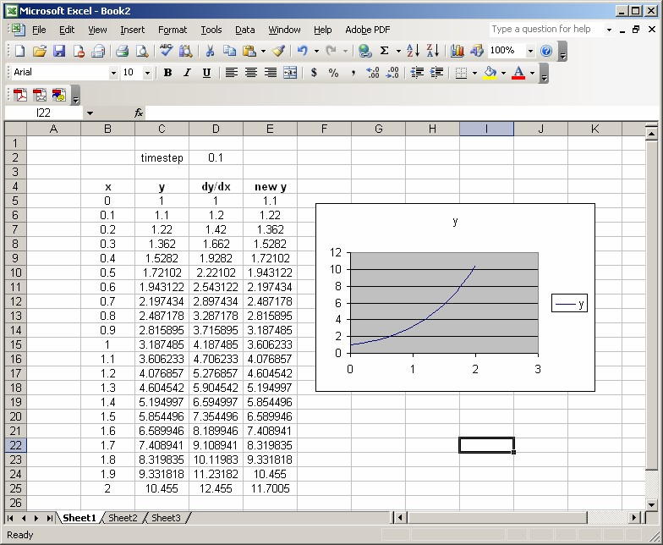

**Changing the timestep:**

One cool consequence of doing Euler’s Method in Excel like this, is that, if you want to use the same IVP, and change only the timestep, all you have to do is edit the timestep value (cell D2 for us) in the spreadsheet. The entire table, and even the plot, updates automatically. For instance, if we change the value in cell D2 from 0.1 to 0.05, our spreadsheet turns into this:

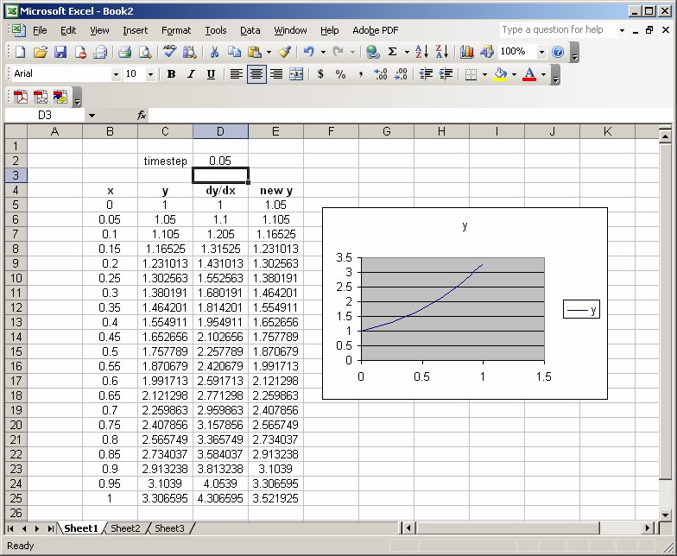

The catch is this: If you make the timestep smaller, your table won’t go all the way to *x*=1, so you’ll have to drag the last row down further to get there.

**Changing the initial condition:**

Everything also updates automatically if we change the initial condition. We change the initial condition by editing the first entries in the x and y columns. For example, to change from the initial condition *y*(0) =1 to *y*(0) = 2 , we enter the value 2 into cell C5. Our spreadsheet then turns into this:

